****Mid-Topic test Revision Sheet for EXTENSION SOLUTIONS****

1. A man walks 3 km south and then 2km west. Determine:
2. the distance travelled
3. The man’s displacement

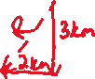

1. Distance = 5 km
2. Displacement (s) : $R= \sqrt{{(3}^{2}+2^{2}}$ = 3.61 km



1. A robot travels 12.5 m west then spins and moves 24.6 m south. The whole journey takes 1.50 minutes.

a) Draw a vector diagram of the robot’s journey

b) Determine the distance travelled.

c) What is the robot’s displacement?

d) Determine the robot’s the average speed.

e) Determine the robot’s average velocity.

f) If the fineness of the scale used to measure the length and time were 0.05 m and 0.02 s respectively, determine the absolute and percentage uncertainty of the lengths and times measured

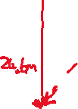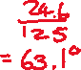

1. For q 22 on General REVISION sheet find the velocity of David for period interval:



1. 0-30 mins



1. 30-60 mins

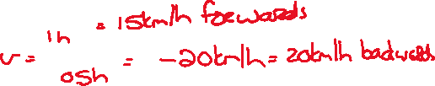

1. 90-120 mins.



1. For q 25 on General REVISION sheet the toddler first travels North. Determine the velocity of toddler at the following times:



1. 20s



1. 55s



1. 70s



1. 100s

